Project Based Learning-II Report
on
“GLAUCOMA DETECTION USING
DEEP LEARNING ”


FACULTY OF ENGINEERING AND TECHNOLOGY
B. Tech
(Computer Science and Medical Engineering)
A.Y. 2024-25



DATTA MEGHE INSTITUTE OF HIGHER
EDUCATION AND RESEARCH
(Deemed to be University)
SAWANGI WARDHA

DECLARATION BY STUDENT(S) – PROJECT BASED LEARNING-II

To, Date – 07/03/2025
The Project Coordinator,
FEAT,
DMIHER, Sawangi
Wardha - 442001

Subject: Candidate Declaration on Project Based Learning-II

We hereby declare that the Project Report titled “Glaucoma Detection Using Deep Learning” submitted by us to Faculty of Engineering and Technology, Datta Meghe Institute of Higher Education and Research in partial fulfillment of the requirement for the award of the degree of B.Tech in Computer Science and Medical Engineering. We further declare that the project report has not been copied, duplicated or plagiarized from any other paper, journal or book and has not been submitted to any education institute or otherwise for the award of any certificate, diploma or degree.
This is an authentic piece of work and in case there is any query regarding the same, We shall be held responsible for answering any queries in this regard.

S. No. | Name | Roll No. | Sign
1 | Aditya Shete | DMET1523021

Mentor Signature Project Coordinator Dean Academics Dean, (FEAT)

ACKNOWLEDGEMENT

We feel immense pleasure to introduce “ Glaucoma Detection Using Deep Learning ’’ as our PBL-II project.
During the entire project duration, We have learned lots of different topics and it was a great opportunity for us to enhance our skills and learn new things essential in today’s world.
Firstly, we would like to thank Dr.Subodh Daronde to guide us along the complete project duration and help us whenever we were stuck at some point. Even got to know how we are surrounded with security in our day-to-day life.
Also, we are thankful to our friends who are always there to support us and helped us with our project by guiding and giving their valuable suggestions which were very useful for us while completing our report.
Finally, we would like to thank all the people who helped us during our internship and for supporting and giving us their valuable time.
Thank You!
TABLE OF CONTENTS

Page No [1-2]

1. Introduction………………………………………………………………………………………..
1.1 Applications …………………………………………………………………….….………..

1.1.1 Early Detection and Diagnosis.…………………….…………………….………………

1.1.2 Retinal Image Analysis…………………………………………………………………..

1.1.3 Automated Screening Systems ……………………………………………………………

1.1.4 AI-Assisted Decision Support Systems …………………………………………………..

1.1.5 Personalized Treatment Plans…………………………………………………………….
Page No. [3-9]
2. Literature Review……………………………………………………………………………………
3. Data set used………………………………………………………………………………………...
3.1 Data collection………………………………………………………………………………….
3.4 Challenges………………………………………………………………………………………
4. Challenges …………………………………………………………………………………………..
4.1 Data-Related Challenges………………………………………………………………………..
4.1.1 Limited Availability of Annotated Datasets…………………………………………………..
4.1.2 Class Imbalance……………………………………………………………………………….
4.1.3 Variability in Fundus Images…………………………………………………………………
4.1.4 Lack of Large-Scale Public Datasets………………………………………………………...

4.2 Model Development Challenges………………………………………………………………..
4.2.1 Overfitting Due to Small Dataset Size………………………………………………………...
4.2.2 Interpretability of Deep Learning Models……………………………………………………..
4.2.3 Deployment and Real-World Challenges……………………………………………………...
4.2.4 Regulatory and Ethical Concerns……………………………………………………………...
5. DETAILS OF PROGRAMMING USED…………………………………………………………………...
5.1. Programming Language and Libraries………………………………………………………………….
5.2. Data Pr-processing……………………………………………………………………………………….
5.3. Training and Testing Data Split…………………………………………………………………………
5.4. Convolutional Neural Network (CNN) Model…………………………………………………………..
5.5. New Data as Input………………………………………………………………………………………...
5.6. Calculated Outpu………………………………………………………………………………………….
6. Methodology……………………………………………………………………….……………….
6.1 Dataset Preparation……………………………………………………………………………...
6.2 Data Pre-processing…………………………………………………………………………......
6.3 Data Augmentation……………………………………………………………………………...
6.4 Feature Selection……………………………………………………………………………......
6.5 Feature Extraction & Classification using CNN………………………………………………..
6.6 Model Training & Performance Improvement………………………………………………….
7. Result………………………………………………………………………………………………..
8. Conclusion…………………………………………………………………………………………..
9. References…………………………………………………………………………………………...

- INTRODUCTION :-

A glaucoma is a group of eye diseases that result in damage to the optic nerve (or retina) and cause vision loss. Risk factors for glaucoma include increasing age, high pressure in the eye, a family history of glaucoma, and use of steroid medication. About 70 million people have glaucoma globally, with about two million patients in the United States. It is the leading cause of blindness in African Americans. It occurs more commonly among older people, and closed-angle glaucoma is more common in women.
Glaucoma has been called the "silent thief of sight" because the loss of vision usually occurs slowly over a long period. Screening for glaucoma is usually performed as part of a standard eye examination performed by optometrists and ophthalmologists. Testing for glaucoma includes measurements of the intraocular pressure using tonometry, anterior chamber angle examination, or gonioscopy as well as an examination of the optic nerve to discern visible damage, changes in the cup-to-disc ratio, rim appearance, and vascular change. Glaucoma detection helps to detect glaucoma from fundus image of their eye.

This report aims to explore the application of deep learning in the early detection of glaucoma. We will discuss the current state of research, the types of data used for training deep learning models, the architectures and algorithms employed, and the challenges and limitations faced in this field. Additionally, we will highlight the potential benefits of DL-based detection systems, including improved diagnostic accuracy, reduced screening time, and the possibility of detecting glaucoma at an earlier stage than traditional methods allow.

The integration of deep learning into glaucoma diagnostics has the potential to revolutionize early intervention strategies. By providing objective, automated, and highly accurate tools for clinicians, DL can enhance screening programs and ensure that individuals at risk receive prompt medical attention. This, in turn, can lead to better management of the disease and a significant reduction in vision loss worldwide.

In the following sections, we will delve into the methodologies, findings, and implications of using deep learning for glaucoma detection and consider the future directions of this promising area of research. Deep learning has been increasingly applied in ophthalmology, aiding in various aspects of glaucoma detection, diagnosis, and progression monitoring.

1.1 APPLICATIONS :-
1. Early Detection and Diagnosis
- AI-powered deep learning models analyze retinal fundus images to detect glaucoma at an early stage, even before significant vision loss occurs.
- Helps in identifying subtle patterns in optic nerve damage that may not be visible to human experts.
2. Retinal Image Analysis
- Automated feature extraction from fundus images detects changes in the optic disc, cup-to-disc ratio, and nerve fiber layer thickness.
- Enhances diagnostic accuracy by reducing human error in manual image analysis.
3. Automated Screening Systems
- Deep learning-based systems enable large-scale screening programs, particularly in remote areas with limited access to ophthalmologists.
- Reduces the burden on healthcare professionals by filtering non-glaucomatous cases, allowing specialists to focus on high-risk patients.
4. AI-Assisted Decision Support Systems
- Provides ophthalmologists with a second opinion by highlighting areas of concern in retinal images.
- Predicts disease progression and assists in monitoring treatment effectiveness over time.
5. Personalized Treatment Plans
- AI models analyze patient-specific risk factors such as intraocular pressure (IOP), optic nerve health, and genetic predisposition.
- Helps in tailoring treatment strategies, including medication adjustments or surgical interventions.

- LITERATURE REVIEW
Figure 1
S.No. | paper/Author | Findings | Technique | Limitations
1. | Ruben Hemelings, Bart Elen, Joao Barbosa-Breda, Matthew B. Blaschko, Patrick De Boever & Ingeborg Stalmans | -The modified the training images in a standardized manner, this study revealed a recurrent pattern in inferotemporal and superotemporal regions neighboring the ONH and the ONH itself.  H | -The classification CNN | -The proposed model did not explicitly assess the influence of myopic changes, did not analyze the role of the disease stage.
2. | Nagana gouda Patil1 & Preethi N. Patil & P. V. Rao | Image size is the first evaluation with learning rate of 0.1, 0.01, 0.001 and 0.0001. The high performance is achieved with 0.001 learning rate. | deep learning (DL), with deep-belief network (DBN) | Dataset used is an unbalanced dataset totally 20.92% glaucoma images together with 79.08% normal images are used.
3. | Oluwatobi Joshua Afolabi , Gugulethu P. Mabuza-hocquet , Fulufhelo V. Nelwamondo, And Babu Sena Paul | -The use of CDR threshold of 0.6 may only be suitable for this database. It was found out that extracting 5 features did not give a full view of the changing geometry of the optic cup and disc and extracting more than ten (10) features only resulted into duplication of data | -U-Net Lite and Extreme Gradient Boost (XGB) | - The proposed model  does not works on low quality images.
4. | Min Liao, BeiJi Zou, RongChang Zhao, Yuan Qiong Chen, ZhiYou He, and MengJie Zhou, | -The researchers observed that the result of glaucoma diagnosis is improved with the increasing of optic disc segmentation,removed batch normalization layers and drop out reduced to 0.2 to reduce the overfitting model. | - novel clinical interpretable ConvNet architecture (EAMNet) | - This model is worked on ORIGA dataset which is unbalanced dataset because it contains 168 glaucomatous and 482 normal fundus images.
5. | Guangzhou An, Kazuko Omodaka, Kazuki Hashimoto, Satoru Tsuda,  Yukihiro Shiga, Naoko Takada,Tsutomu Kikawa, Hideo Yokota,  Masahiro Akiba and Toru Nakazawa | -The machine learning system described can accurately differentiate between healthy and glaucomatous subjects based on their extracted  images from OCT data and color fundus images. | - optical coherence tomography and Transfer learning of convolutional neural network | -This study include a relatively small study  population.
6. | Glaucoma Diagnosis in the Era of Deep Learning: A Survey. Mona Ashtari-Majlan et al. | Deep learning techniques such as CNNs, autoencoders, and GANs have improved glaucoma detection accuracy. Emphasizes the need for multi-modal data integration and explainability | CNNs, attention networks, GANs, geometric deep learning models | Need for larger datasets, challenges in clinical translation, and explainability issues.
7. | Machine Learning Applied to Retinal Image Processing for Glaucoma Detection: Review and Perspective.  Daniele M. S. Barros et al | ML-based glaucoma diagnosis is feasible and promising; deep learning models perform better with data augmentation and transfer learning | Feature extraction, deep CNNs, dimensionality reduction, SVM | High computational costs and the need for large labeled datasets.
8. | Glaucoma Detection and Classification Using Improved U-Net Deep Learning Model.  Ramgopal Kashyap et al | An improved U-Net with DenseNet-201 showed 98.82% training accuracy and 96.90% testing accuracy. | U-Net segmentation, DenseNet-201 deep CNN | Requires further validation on external datasets and improvement in generalization.
9. | Glaucoma Diagnosis Using Multi-Feature Analysis and a Deep Learning Technique. Nahida Akter et | A deep learning model trained on structural, functional, and demographic features achieved high accuracy (97% validation, 96% test) | ] Deep learning (DL), logistic regression (LR), Grad-CAM visualization | Model performance varied slightly on test data, indicating a need for larger datasets
10. | Glaucoma Detection Using Fundus Imaging and AI. Romanian Journal of Ophthalmology | Fundus imaging and AI significantly enhance glaucoma detection accuracy. | Fundus imaging, OCT, AI-based segmentation | Subjective interpretation limitations in some diagnostic methods.

- DATASET USED

  - ACRIMA
ACRIMA database is composed by 705 fundus images All images from ACRIMA database were annotated by glaucoma experts with several years of experience. They were cropped around the optic disc and renamed.

  - DRISHTI-GS

- This Dataset contains 50 train images and 51 test Images. In Each Directory there are two folders one is images and the second one is GT. The later folder contains Optic Disk and Cup masks associated with the images in the Images folder.

  - RIMONE

- The RIM-ONE database contains 169 optic nerve head images. Each image has 5 manual segmentations from ophthalmic experts. A gold standard for each image was created from its corresponding segmentations.

4. Challenges :-

- 4.1 Data-Related Challenges

- 4.1.1 Limited Availability of Annotated Datasets

- High-quality, labeled glaucoma datasets are scarce, making it difficult to train deep learning models effectively.Expert annotation of fundus images is time-consuming and requires specialized ophthalmologists.

- 4.1.2 Class Imbalance
- Glaucoma cases are fewer than normal cases in most datasets, leading to class imbalance problems.Biased models may favor non-glaucomatous cases, reducing sensitivity in detecting glaucoma.

- 4.1.3 Variability in Fundus Images

- Differences in image acquisition (lighting conditions, resolution, and camera types) can lead to inconsistent results. Retinal images from different populations may have variations that affect model generalization.

- 4.1.4 Lack of Large-Scale Public Datasets
- Unlike other medical imaging domains, publicly available large-scale glaucoma datasets are limited.Ethical and privacy concerns restrict data-sharing across institutions.

4.2 Model Development Challenges

4.2.1 Overfitting Due to Small Dataset Size

- Deep learning models require large amounts of training data; small datasets increase the risk of overfitting. Models may learn dataset-specific features rather than generalizable glaucoma characteristics.

4.2.2 Interpretability of Deep Learning Models
Most CNN-based models act as black boxes, making it difficult for ophthalmologists to trust AI decisions. Lack of explainability hinders clinical adoption, as doctors need to understand why a model makes a diagnosis.

4.2.3 Deployment and Real-World Challenges

AI models must be seamlessly integrated into hospital systems and electronic health records (EHR). Many ophthalmology centers lack the infrastructure to deploy deep learning models.

4.2.4 Regulatory and Ethical Concerns

AI models for medical diagnosis must comply with FDA, CE, and other regulatory approvals before deployment. Ethical issues related to patient data privacy and AI bias need to be addressed.

5.DETAILS OF PROGRAMMING USED

5.1. Programming Language and Libraries
Language: Python is selected due to its extensive support for deep learning and computer vision tasks.
Libraries:
- NumPy and Pandas: Used for data manipulation, such as cleaning and organizing retinal image datasets.
- OpenCV: Used for image processing, including resizing, filtering, and enhancing fundus images.
- TensorFlow/Keras or PyTorch: Core deep learning frameworks for implementing and training CNN models.
- Scikit-learn: Used for performance evaluation metrics such as accuracy, precision, recall, and AUC-ROC.
- Matplotlib and Seaborn: Assist in visualizing data, model training progress, and performance evaluation.
5.2. Data Pre-processing
Loading Data:
- The first step involves importing fundus images from publicly available datasets (e.g., ACRIMA, Drishti-GS).
- Labels indicate whether the image belongs to a glaucoma-positive or glaucoma-negative patient.
Cleaning the Data:
- Handling missing or corrupted image files.
- Removing duplicate or low-quality images that may affect model training.
Normalization:
- Rescaling pixel values (0 to 255) to a standard range (0 to 1) for efficient neural network processing.
Data Augmentation:
- Techniques like rotation, flipping, contrast adjustment, and blurring are applied to generate more training samples and improve model generalization.
Feature Extraction:
- Extracting key retinal features such as optic nerve head shape, cup-to-disc ratio, and vessel structures to assist in classification.

5.3. Training and Testing Data Split
Dataset Division:
- The dataset is divided into training (70%) and testing (30%) to evaluate the model’s performance on unseen data.
- A validation set (typically 10-20% of the training set) is used for tuning hyperparameters and preventing overfitting.
Stratified Sampling:
- Ensures both glaucoma and non-glaucoma cases are equally represented in the training and testing sets.

5.4. Convolutional Neural Network (CNN) Model
CNN Model Setup:
- A Convolutional Neural Network (CNN) is selected due to its efficiency in image classification.
- The model extracts and learns features such as optic disc deformation, cup size, and nerve fiber thinning from fundus images.
Model Architecture:
- Convolutional layers for feature extraction.
- Pooling layers for dimensionality reduction.
- Fully connected layers for classification.
Hyperparameter Tuning:
- Optimizing key parameters such as the number of layers, filter sizes, dropout rates, learning rate, and activation functions to improve performance.
Optimization Algorithm:
- Adam optimizer is used to speed up convergence.
- Categorical cross-entropy loss function is applied for binary classification (glaucoma vs. non-glaucoma).

5.5. New Data as Input
Real-World Image Input:
- After training, the model can take new retinal fundus images as input for glaucoma detection.
- Pre-processing steps (resizing, normalization, and augmentation) are applied to ensure compatibility with the trained model.
Automated Screening:
- The system can be integrated into clinical settings for AI-assisted glaucoma screening.

5.6. Calculated Output
Glaucoma Prediction:
- The CNN model outputs a classification result: Glaucoma (Positive) or Non-Glaucoma (Negative).
- A probability score is provided to indicate the confidence level of the prediction.
Performance Evaluation:
- The model’s effectiveness is evaluated using:
  - Accuracy (percentage of correctly classified cases).
  - Precision and Recall (to check how well glaucoma cases are detected).
  - AUC-ROC Curve (to assess classification quality).
  - Confusion Matrix (to visualize true positives, false positives, etc.).
Visualization of Results:
- Heatmaps (Grad-CAM) are used to highlight which retinal areas the model focuses on during classification.
- Graphs and loss curves are plotted to analyze model training performance.

6. Methodology
6.1 Dataset Preparation
Three different glaucoma datasets were combined to create a larger dataset, improving model performance and generalization. A larger dataset helps reduce overfitting and enhances robustness. Image quality is checked to remove corrupted or low-resolution images, ensuring only high-quality data is used for training.
6.2 Data Pre-processing
Pre-processing converts raw fundus images into a structured format suitable for deep learning. Missing or inconsistent image data is handled to maintain accuracy. Image resizing ensures uniform resolution for CNN input. Color processing involves converting images to grayscale or retaining RGB format based on model requirements. Contrast enhancement improves visibility of key retinal features, while noise reduction filters out distortions. Normalization scales pixel values between 0 and 1, ensuring better convergence during model training.
6.3 Data Augmentation
Data augmentation artificially increases dataset size to enhance model generalization. Techniques such as random rotation, horizontal and vertical flipping, and brightness adjustments create diverse variations of images. Zooming and cropping focus on key areas like the optic nerve head. Gaussian blur smoothens images to reduce noise while retaining important details. Augmentation ensures the model is exposed to different variations of fundus images, improving its ability to detect glaucoma under different conditions.
6.4 Feature Selection
Feature selection extracts crucial image characteristics for glaucoma diagnosis. Optic disc and cup segmentation are identified to locate the affected region. The cup-to-disc ratio (CDR), a key clinical parameter, is calculated to detect abnormalities. This step ensures that only the most relevant features are used, improving model accuracy and efficiency. Edge detection techniques help highlight the boundaries of the optic disc and cup for precise analysis.
6.5 Feature Extraction & Classification using CNN
A Convolutional Neural Network (CNN) is used for automatic feature extraction and classification. CNN eliminates the need for manual feature engineering by detecting spatial patterns in fundus images. Convolution layers identify image features such as edges and textures. Pooling layers reduce dimensionality while preserving essential details. Fully connected layers interpret extracted features and make classification decisions. Activation functions like ReLU introduce non-linearity, improving model efficiency. Dropout layers prevent overfitting by randomly deactivating some neurons during training.
6.6 Model Training & Performance Improvement
CNN is trained using labeled fundus images to classify glaucoma-positive and glaucoma-negative cases. Optimization techniques like the Adam optimizer adjust model weights efficiently. Loss functions such as categorical cross-entropy are used for multi-class classification. Batch normalization stabilizes training by reducing internal covariate shifts. Hyperparameter tuning optimizes batch size, learning rate, number of layers, and filter sizes. Model evaluation metrics include accuracy, precision, recall, and the AUC-ROC curve to assess performance. Visualization techniques like Grad-CAM highlight important regions influencing model decisions.

Figure 2
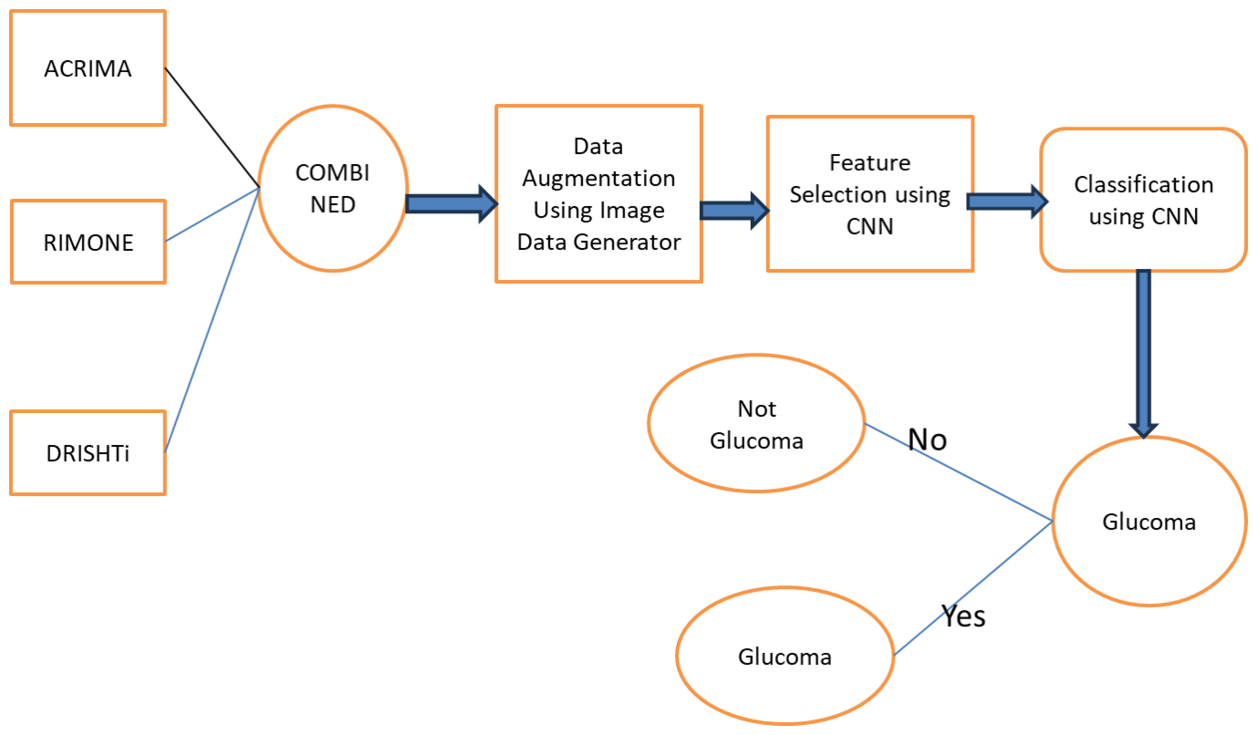

7.RESULTS

Figure 3
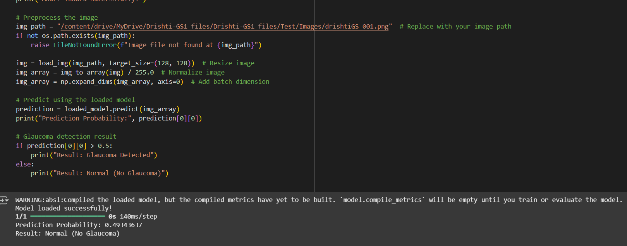
8. CONCLUSIONS
Permanent blindness is brought on by the complication of glaucoma, which is connected to optic nerve damage. The use of glaucoma detection will expand thanks to this method of medical image processing technology. The computer-generated results from this work will help to raise the bar for clinical judgment when it comes to glaucoma identification. Because there are more normal fundus photos in the dataset, this algorithm can detect the glaucomatous images correctly. The proposed methodology uses an image data generator for data augmentation. The original images have increased due to augmentation and a large dataset is prepared. Later the augmented images have been sent for feature selection using CNN. The images are classified using binary classification as it has two outcomes. The proposed system achieved an accuracy of 81. 47% which is noteworthy in this field.

9. References

- Hemelings, R., Elen, B., Barbosa-Breda, J. et al. Deep learning on fundus images detects glaucoma beyond the optic disc. Sci Rep 11, 20313 (2021). Doi: https://doi.org/10.1038/s41598-021-99605-1
- Patil, N., Patil, P. N., & Rao, P. V. (2021). Convolution neural network and deep belief network (DBN) based automatic detection and diagnosis of Glaucoma. Multimedia Tools and Applications, 80(19), 29481–29495. Doi: 10.1007/s11042-021-11087-5.
- O. J. Afolabi, G. P. Mabuza-Hocquet, F. V. Nelwamondo and B. S. Paul, "The Use of U- Net Lite and Extreme Gradient Boost (XGB) for Glaucoma Detection," in IEEE Access, vol. 9, pp. 47411-47424, 2021, doi: 10.1109/ACCESS.2021.3068204.
- W. Liao, B. Zou, R. Zhao, Y. Chen, Z. He and M. Zhou, "Clinical Interpretable DeepLearning Model for Glaucoma Diagnosis," in IEEE Journal of Biomedical and Health Informatics, vol. 24, no. 5, pp. 1405-1412, May 2020, Doi: 10.1109/JBHI.2019.2949075.
- An, Guangzhou, et al. "Glaucoma diagnosis with machine learning based on optical coherence tomography and color fundus images." Journal of healthcare engineering 2019 (2019), Doi: https://doi.org/10.1371/journal.pone.0207982

